1. Given a sample 'users' table with columns (id, username, email, city, age, signup_date), write a SELECT query to display all usernames and emails of users who live in 'Ahmedabad'.

Ans
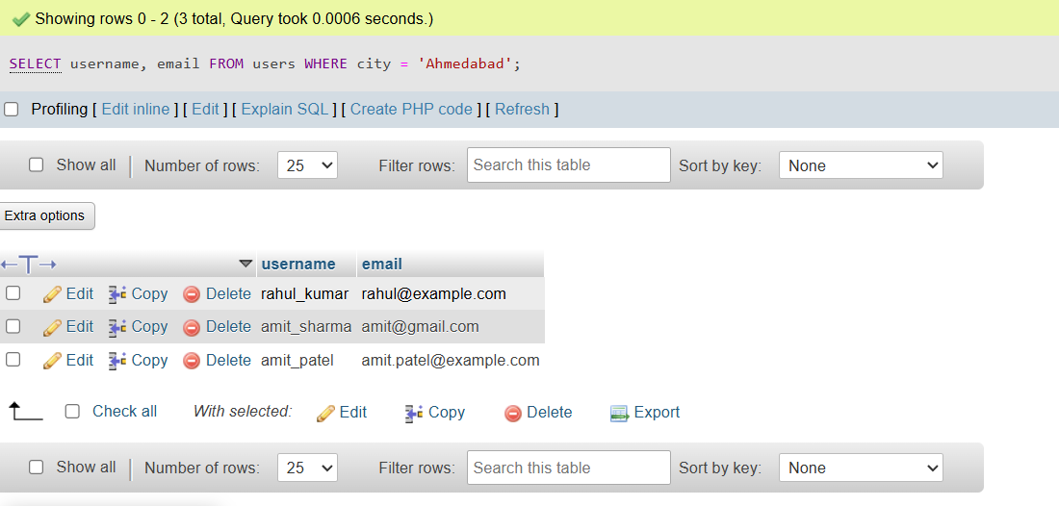

2. Write a SELECT query to find all users whose username starts with 'a' (case-insensitive), using the LIKE operator.
Ans:
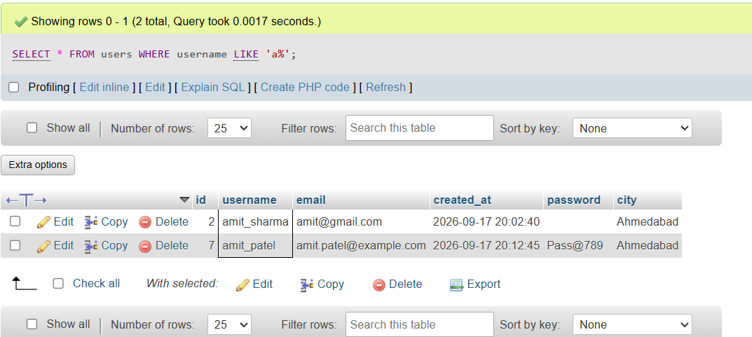

3. Write a SELECT query to list the distinct cities from the users table where at least one user is above 25 years old.
Ans:
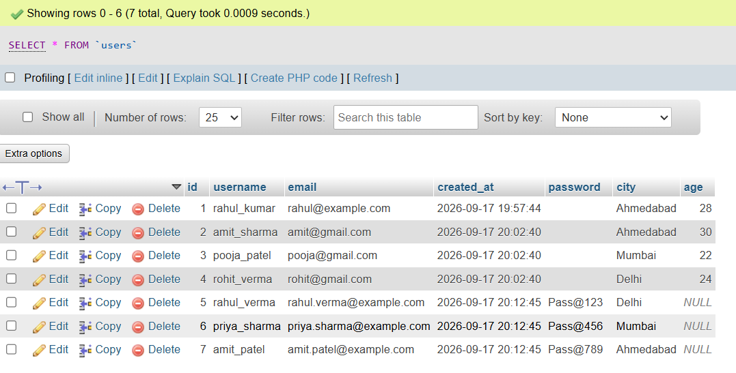

4. Write a SELECT query to show the top 5 most recently signed-up users, displaying their username and signup_date, ordered by signup_date descending.<br><br><em><strong>Hint:</strong> Use ORDER BY and LIMIT together.</em>
Ans:
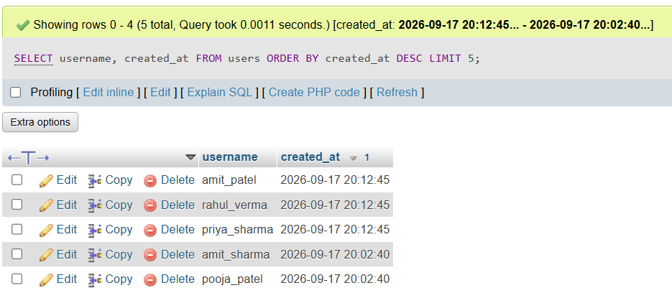

5. Write a SELECT query to find all users whose age is between 18 and 22, and who live in either 'Surat' or 'Vadodara', displaying their username, city, and age.<br><br><em><strong>Constraint:</strong> Use BETWEEN and IN operators in your WHERE clause.</em>

Ans:
